**Can Configurator**

**AUTOSAR Can Configuration Tool**

**1.Over view**

This configurator is used to configure can driver implemented on Tiva C (tm4c123gh6pm) according to Autosar standard release 4.3.1.

It genrates Can_Cfg,h file which is the header files containing configuration to

be used by the static code and arxml(autosar xml) for the can driver.

1. **How to use?**



- The Tool Starts.

**2.1 Configure the Can General**

* Open Can Module.
* Select Can General.
* Configure the Can General

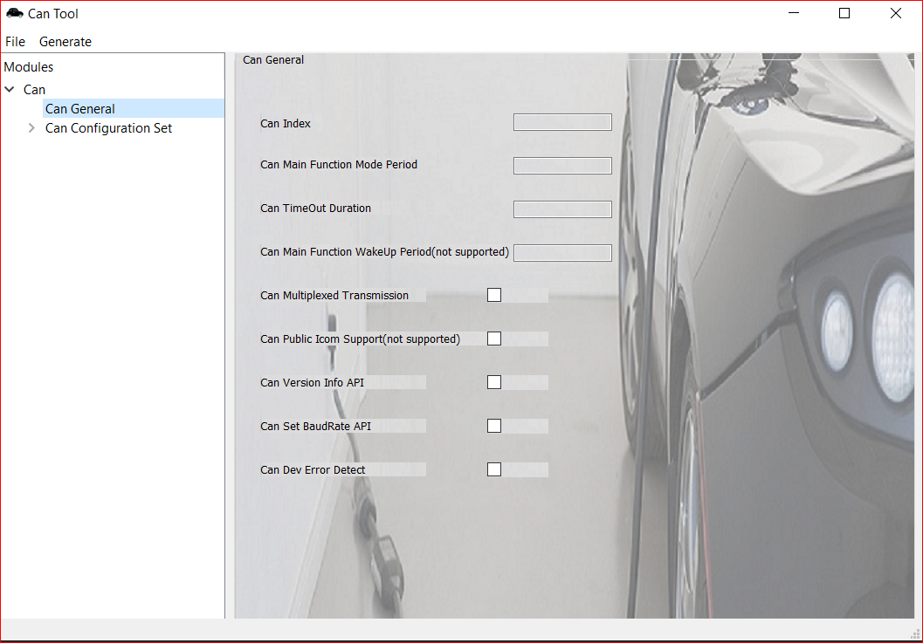

N.B: The two parameters Can Public Icom support and Can Main function wake up period will not be genrated as they are not supported by hardware so they

are denoted (not supported).

**2.2 Add Can controller:**

* Open Can Configuration Set from the tree view.
* Right click on Can Controllers from the tree view.
* Click on Add New Controller.
* Configure the Can controller.

o Fill in all parameters .

o Fill in the Baud Rate Config.

o Add Can Controller Baud Rate Config. ‘if wanted’-Will see how to add later-

o After adding all Baud Rate Configs, go and choose the Default Baud Rate config.

Initially each Can controller has one Baud Rate Configuration. But, each can controller can has many Can BaudRate Configurations. So, there’s an option to add baud rate configurations to any of the controllers. We will introduce how this can be done later.

So, now we are going to fill in the values of Can Controller_1 parameters and its sub-container ‘CanController BaudRate Configuration.



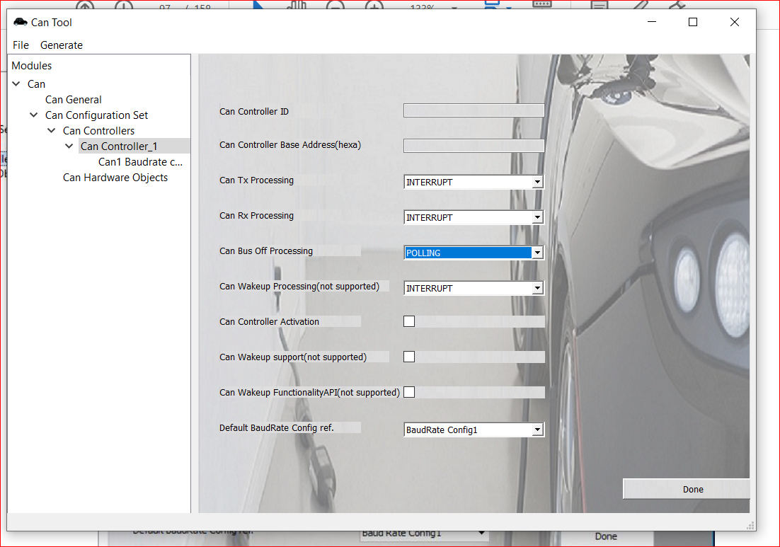

**N.B:**

-Tx and Rx processing can be configured as interrupt or polling only.Mixed mode is not supported by hardware.

-Also, Tx and Rx processong must be configured that both of them are interrupt or both are polling (hardware constraint).

-Can Wake up Functionality ,Can Wakeup support and Can Wakeup processing are not supported by hardware.

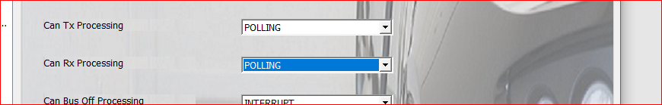

-The deafualt Baud Rate is the baude rate that the controller wiil operate with when being firstly initialised so you can choose one from your Baud rate configurations to be the default one.

**2.3. Adding more Baud Rate configurations to a specific can controller:**

* Open Can Configuration Set from the tree view.
* Open Can Controllers then select the required controller.
* Right click and choose Add New BaudRate Config.
* Configure the BaudRate Configuration.
* Click DONE

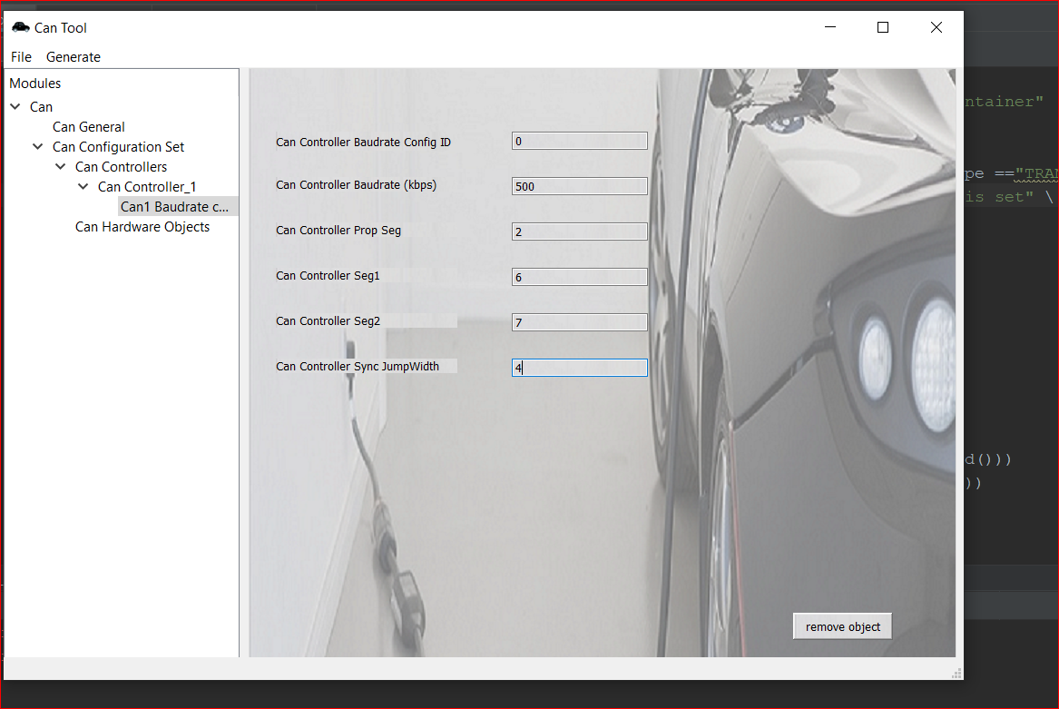

-The baudrate shall be entered in kbps to get the required operation rate by hardware it must be greater than zero and less than or equal 1000.

-The values of all paremeters have restictions and you can’t assign any values to them. For more info. lookup the tiva C data sheet CAN section.

**2.4. Add New Hardware Object:**

* Right click on Can Hardware Objects in tree view.
* Choose Add New Hardware Object.
* Configure the Hardware Object.

o Fill in all Can Hardware object Parameters.

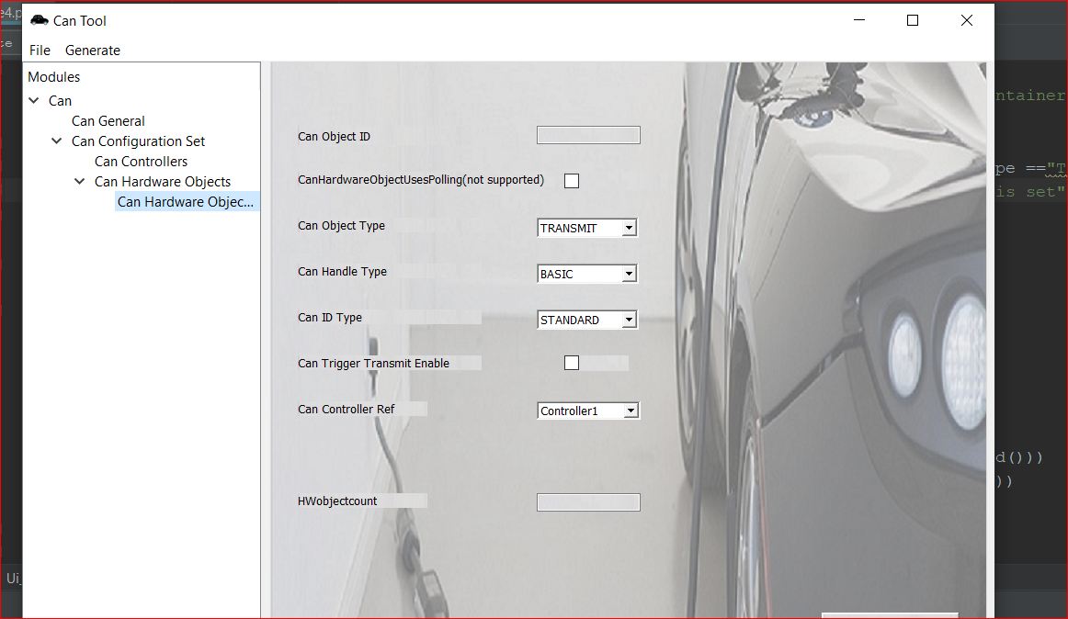

**N.B:**

-You shall take care that summation of Hwobjectcount for hardwareobjects mapped to one controller must no exceed 32.

**2.4.1 Add filter container**

-If you configured Can Object type as “RECEIVE” you must create a filter container.



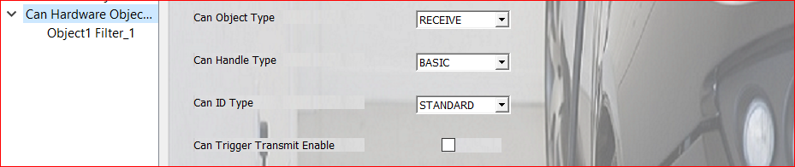

-The filter container contains two paremers the filter code which determines the ID to be received by this hardware object and the filter maske which is used to create a range of IDs.

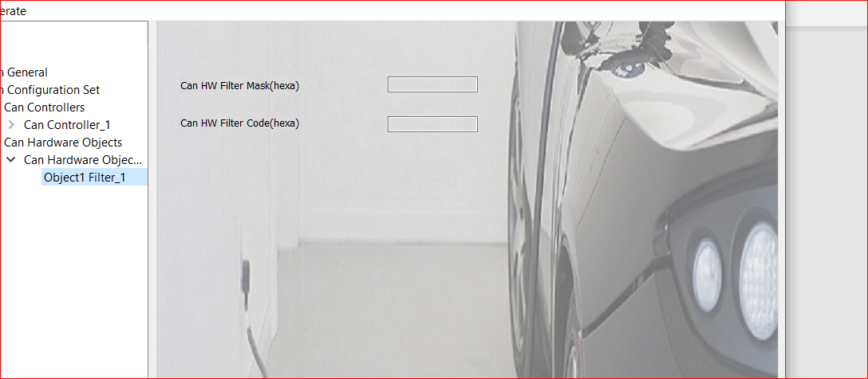

To create a range of IDs the object ‘s Can handle types must be BASIC otherwise the mask has to bes set as (FFFFFFFF) to accept messages having

the ID of the filter’s code value.

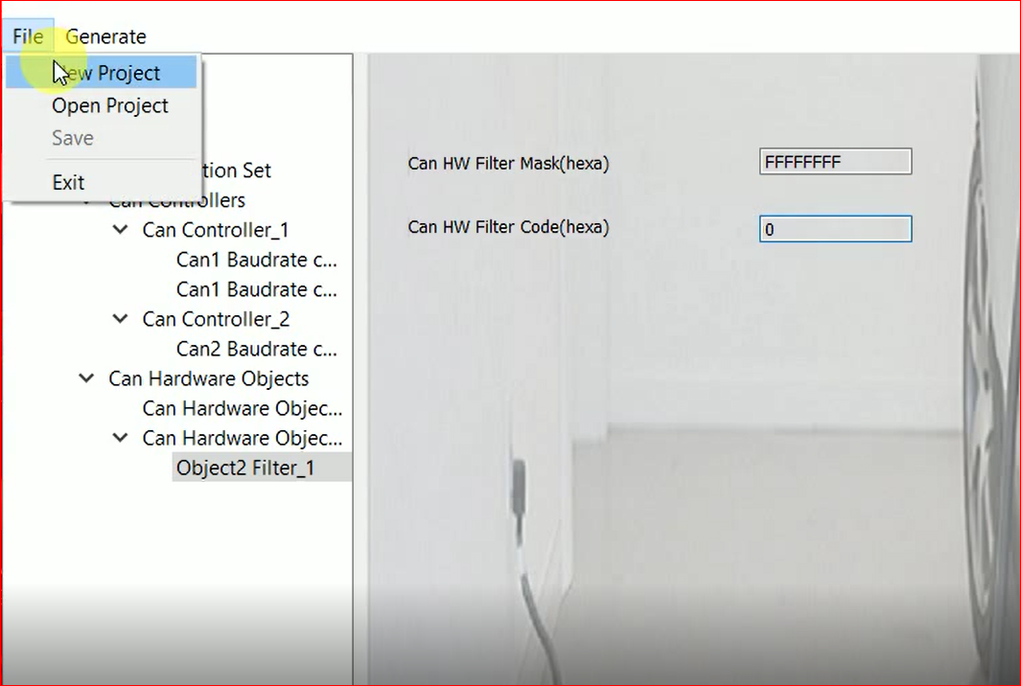

* 1. **Saving your project**

To choose the directory at which your generated files will be saved :

From “file ” choose “New Project”,then choose the directory you want to save generated files at.

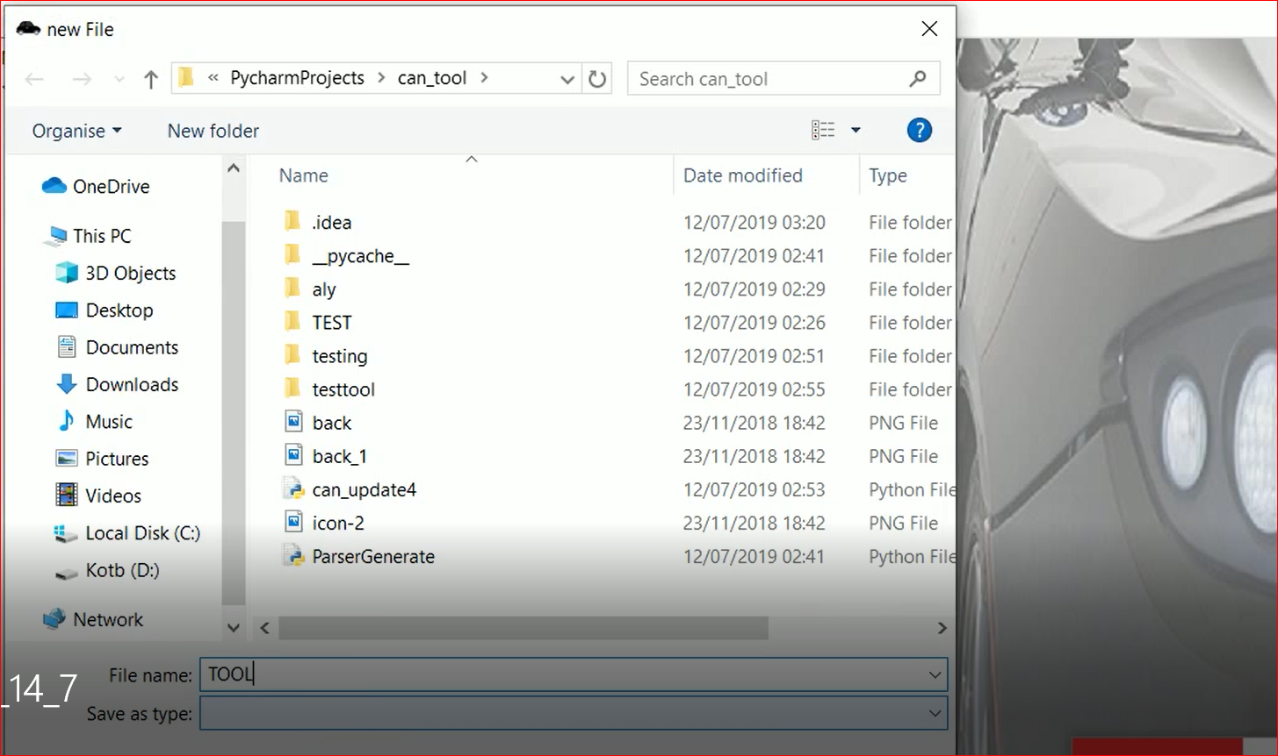

Click generate for your files to be generated, then go to the directory to find your generated files.

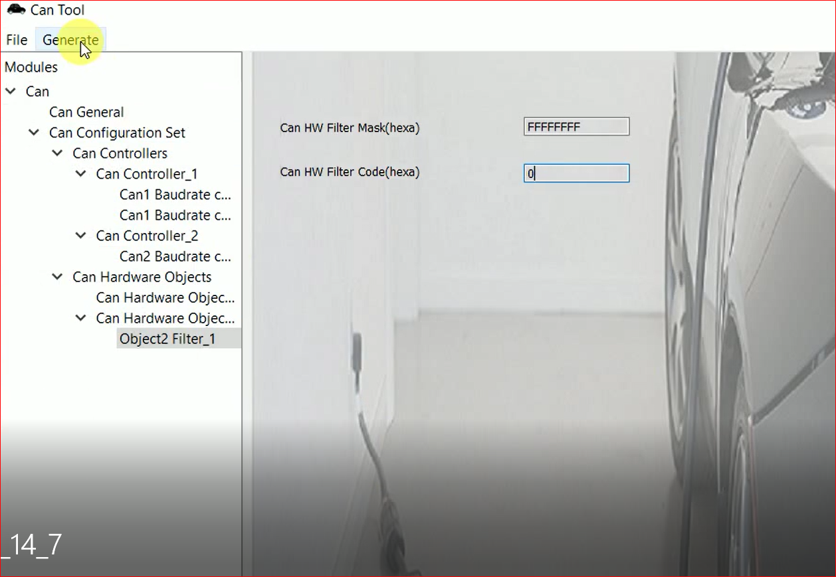

**N.B:**

For more information about any parameter refer to the Autosar SWS of can driver chapter release 4.3.1.